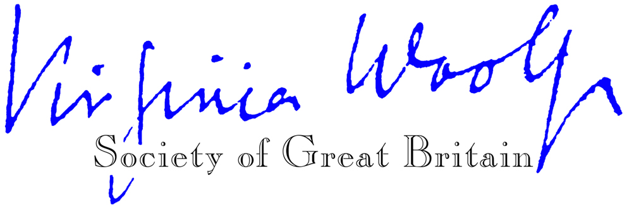
Hon. President: Dame Eileen Atkins

Membership Application / Renewal Form (UK £ sterling)
(Please do not send cheques etc. in currencies other than pounds sterling.)

Please enrol me as a member of the Virginia Woolf Society of Great Britain from

__________________________ to 31 December _________

I: enclose my sterling cheque / enclose an (international) postal order / enclose a bank draft / have made a BACS bank transfer / have made a payment via PayPal online (please delete as appropriate) for £________ made payable to ‘Virginia Woolf Society’.

Title: ___________Name: ____________________________ ______________

Address: __________________________________________________________________

_________________________________________________________________________

Postcode: ________________ Email: ___________________________________________

How did you hear about the Society?

_________________________________________________________________________

Please return your remittance and the completed form to:
Lindsay Martin, Membership Secretary, Virginia Woolf Society, 12 Elm Park Road, London N21 2HN, UK or by email to membershipvwsgb@gmail.com

At the Virginia Woolf Society we take the security of your personal data seriously. We only collect the information from you that we need to fulfil your membership contract. We never sell your information to third parties.

The UK General Data Protection Regulation (GDPR) which came into effect on 1 January 2021 regulates the way we can use personal data and requires us to have consent from you for any contact we make other than for the original purpose for which you gave us data. Since we don’t want you to miss out on information you might like to receive from us (such as event notifications), please tick the box to receive VWSGB informational emails: □

